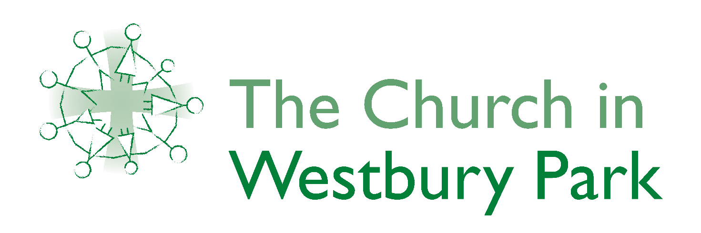.
SAFEGUARDING
The Church in Westbury Park is committed
to making our churches
places where all are safe and protected from abuse,
all can be healed and all can live life to the full.
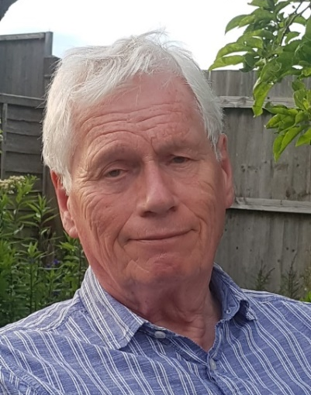
Our Safeguarding Officer is Robin Orbell.
Please contact him if you would like to talk
about any safeguarding matters which concern you.
Robin Orbell
07881 527 295
SafeguardingWPark@outlook.com
For further information about how we seek to make this a reality
please see our policies and procedures
(the full policy is on the main noticeboard in each building, on the website, and in the files on our Facebook page and available from the Church office.)
The Ecumenical Church Council has formally adopted the House of Bishops “Promoting a Safer Church; Safeguarding Policy Statement”
Signed ……………………………………
On the next page you will find information about agencies
and organisations which offer advice, support and help.
If you have been made aware that a child or vulnerable adult is at risk
of harm please follow the Immediate Action flowchart attached.
USEFUL CONTACT INFORMATION

To report a child protection concern or for children’s services:
First Response (Children’s services Bristol City Council) 0117 903 6444

Out of Hours Emergency Duty Team (Evenings and weekends): 01454 615165
For adults and carers in need of social care support:
Care Direct (Bristol City Council) 0117 922 2700

Out of Hours Answerphone
Child protection and support Charities:

The NSPCC (National Society for the Prevention of Cruelty to Children): UK charity specialising in child protection and the prevention of cruelty to children
www.nspcc.org.uk Freephone helpline: 0808 800 5000
https://forms.nspcc.org.uk/content/nspcc---report-abuse-form/

Childline: Free helpline for children and young people in the UK
www.childline.org Freephone helpline: 0800 1111.

Domestic Abuse:

If you are an adult seeking support, please call Next Link on 0800 4700 280
https://nextlinkhousing.co.uk/

National Domestic Violence 24 hour helpline 0808 2000 247

Someone to talk to:

Samaritans: email : jo@samaritans.org 24 hour helpline 116 123

Network Counselling: Affordable counselling service based in Bristol 0117 950 7271

The Green House: Counselling support for men, women and young people who have experienced sexual abuse Mornings 0117 935 1707
info@the-green-house.org.uk

Self Injury Support Tuesdays and Thursdays 1900-2130 0808 800 0808 info@selfinjurysupport.org.uk

Oct 2023

